***Name of the project***

**Movie Information and Analysis for Business Intelligence**



**Team - CodeMask**

|  |  |  |  |
| --- | --- | --- | --- |
|  | **Prepared By** | **Reviewed by** | **Approved By** |
| **Name** | **Shreyajyoti Dutta**  **Nandini Bhargava**  **Vikash Tyagi** |  |  |
| **Role** | **Programmer Analyst Trainee** |  |  |
| **Signature** |  |  |  |
| **Date** | **02-07-2021** |  |  |

**Table of Contents**

**1 Introduction**

**1.1 Objective 3**

**1.2 Target audience 3**

**2 Overview**

**2.1 Proposed System 3**

**2.2 Exclusions 4**

**2.3 Constraints 4**

**3 Data flow diagram 4**

**4 System Requirements**

**4.1 Hardware Requirement 6**

**4.2 Software Requirement 6**

**5 Technologies Used 6**

**6 Static pages and sections 7**

**7 Modules In-depth**

**7.1 Movie Information module 8**

**7.2 Data Visualization module 9**

**8 Conclusion 10**

1. **Introduction**

**1.1 Objective**

Movies are considered as one of the ultimate sources of media and entertainment industry. Each and every year numerous numbers of movies are released across the globe. Some movies entertain its audiences with its pure humor like comedy movies while some provide real insight to the social justice, society & culture and technological enigma.

This project is intended to provide users of all categories some real information about the movies they search for. Besides it will also help users to pull insight from it as it is easy for human brains to understand patterns and colors rather than some dull datasets.

**1.2 Intended Audience**

General

1. **Overview**

**2.1 Proposed System**

The proposed system provides an user interface where the user will be able to search for different movies by typing the movie name as well as search according to genre. On the other hand, users with special rights such as an admin can get a visual outcome of the data in the form of row charts, pie charts, interactive tables etc.

The following are the modules included in the proposed system:-

* Movie information fetching

This module will be used by general users over the internet who wants to get details of their favorite movies. It can be used either by typing the movie name or going by the specific genre.

* Visualizing the data

This module is intended to provide business insight to the end users. By selecting different questions, user is able to get an easy-to- understand graphical representation.

**2.2 Exclusions**

The system will operate only on the modules discussed above and will not include any additional functionality.

**2.3 Constraints**

There are primarily two constraints of the project:-

* The search option in the movie information fetching module is not automated, i.e. the search is not completed automatically while typing.
* The data visualizing module is limited to some pre-set questions.

**3. Data flow diagram**

The following data flow diagram gives a high-level overview about how data is taken into the system and produce the required output as per the requirement of the user.

**Dataset**



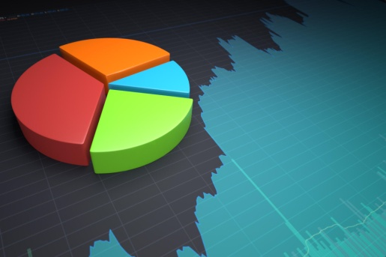

**Reporting tool** to translate output into visualization

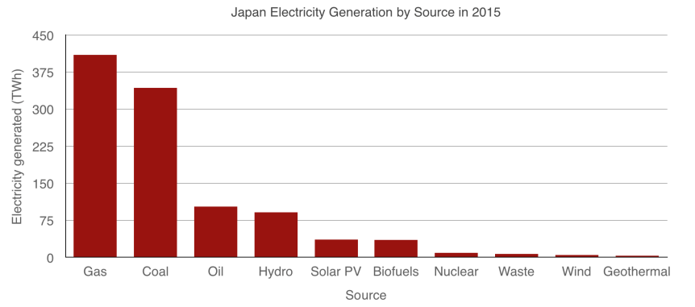

**Web interface** for the end user to access the result

**4. System Requirements**

**3.1 Hardware Requirement**

**RAM –** 2 GB or more

**Hard Disk –** a minimum of 20 GB

**3.2 Software Requirement**

**Operating System –** Windows / Mac / Linux

**Web browser –** Google Chrome / Mozilla Firefox

**5. Technologies used**

* HTML – HTML has been used for the skeleton structure of the webpage.
* CSS – Cascading Style Sheet has been used for designing the pages and making it more user-friendly.
* Bootstrap – An easy to use front-end framework for designing navigation bar, buttons, cards, dropdown-list etc. has been used.
* JavaScript – Different user-interactive functionality like show & hide feature has been done by JavaScript.
* Tableau – A powerful data visualization tool which has been used in the project for generating the reports.

**6. Static pages and sections**

* Home page
* About page
* Movie-info page
* Dashboard page

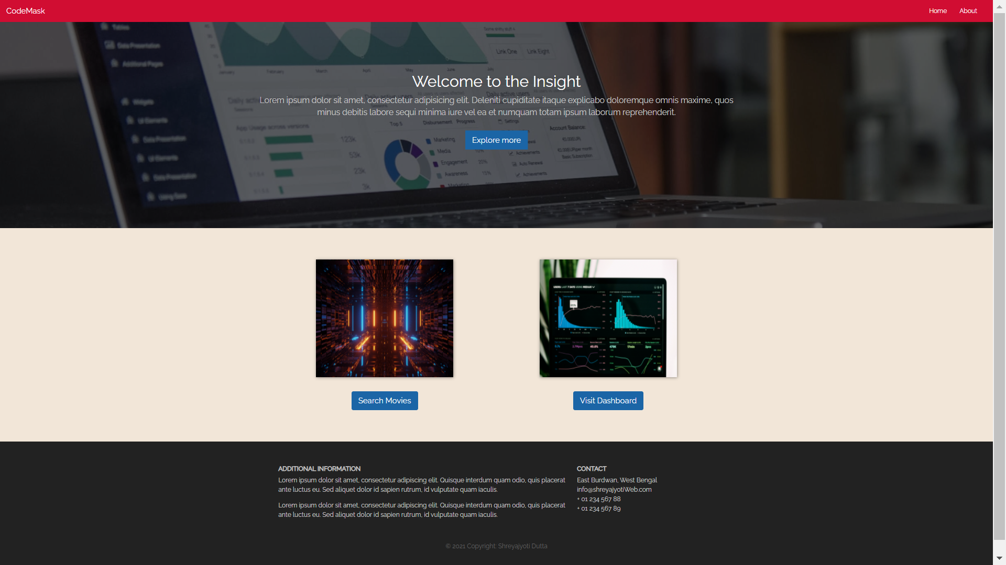

**7. Modules In-Depth**

**7.1 Movie information fetching (Search Movies) module**

The utility of this module lies in providing the user valuable information about the movies he/she is searching for. The search can be conducted in two ways –

* By typing the movie name

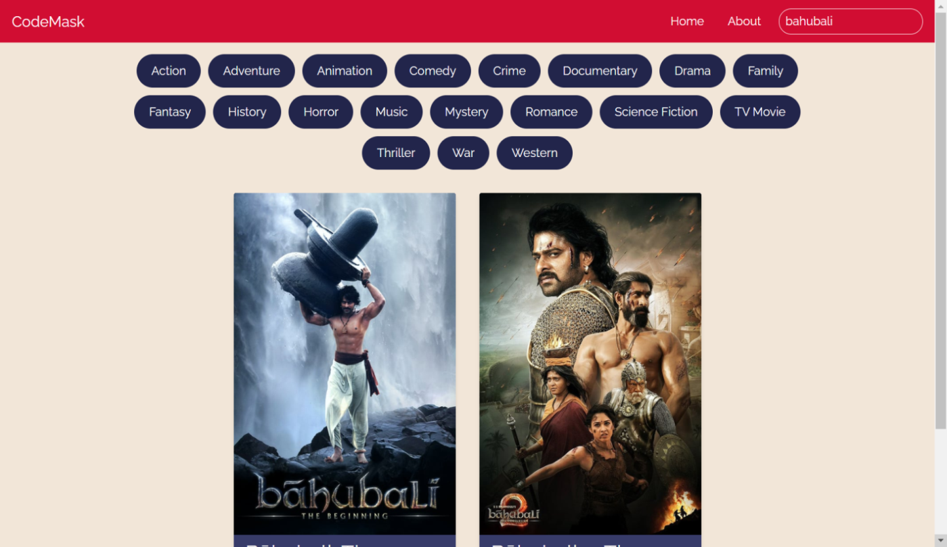

* By selecting the genre

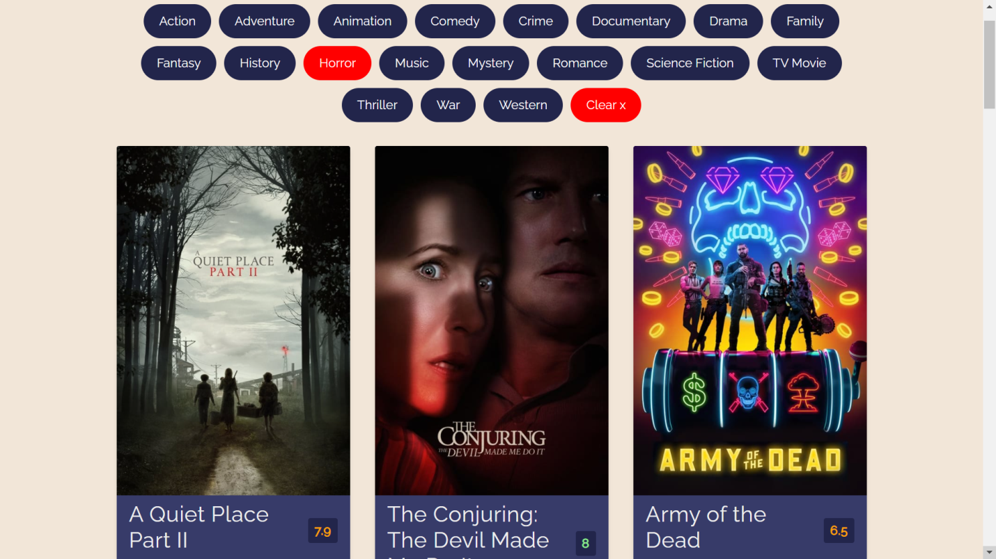

**7.2 Data Visualizing (Visit Dashboard) module**

This module gives a proper insight of the dataset in the form of charts and tables according to the question selected by the user.

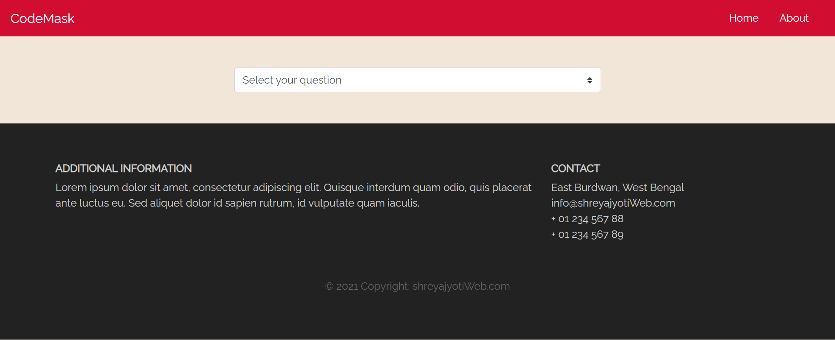

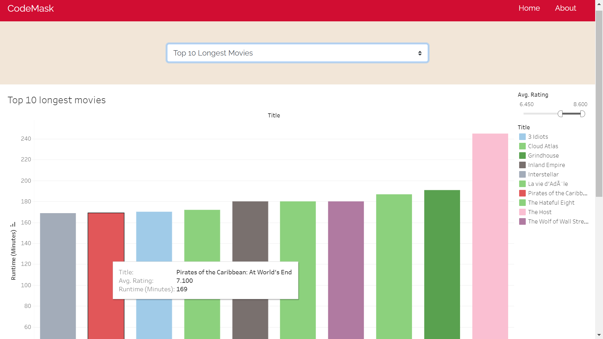

**8. Conclusion**

To sum up, with the increase of the volume of data day by day, it has become a very necessary task to process and analyze those data in proper way. It enables decision makers to see analytics presented visually, so they can grasp difficult concepts or identify new patterns. In this regard, this project can serve the purpose in an efficient way. Besides that, by integrating and implementing other algorithms and technologies, more efficient data drilling and future predictions can be made easily.